The role of background effort in split-belt adaptation
Methods
…
State space learning model: To examine learning rates, we fit step length asymmetry using the state space learning model described in equation %%%. The state space model predicted the participant’s estimate of the rotation, $\hat{y}$, on a given trial $n$, based on recall of the estimate on previous trial and error on the previous trial. The estimate from the previous trial was weighted by a remembering factor, α, which described how much of the previous estimate is remembered in the new estimate. The error from the previous trial is $(y - {\hat{y}}_{n})$, the difference between the actual rotation and the estimated rotation, was weighted by a learning rate, β, which described the participant’s sensitivity to error. Both remembering factor and learning rate are in the interval [0,1].
 | $${\hat{y}}_{n+1} = α{\hat{y}}_{n} + β(y - {\hat{y}}_{n}).$$ | Equation 6
We fitted the model in a custom script using MATLAB’s fmincon function to minimize mean squared error. The state space model captures two important characteristics of motor learning: the rate of learning, describing how quickly a participant adjusts their gait to improve symmetry, and the extent of learning, describing the how close the participant’s asymmetry asymptote is to symmetry. The extent of learning is a function of the forgetting factor and the learning rate because, in the model, the asymptote is the error value at which the remembering term and the error term cancel one another out so that the forgotten portion of the previous trial is recovered by the error term. We compared the terms of state space learning fits between groups using one-way ANOVAs. Results were similar when the data was fit across all strides of the learning block to when the data was fit using only the first 200 strides, therefore the state space fits for the asymmetry curves include all strides in the learning block.
Exponential fit of learning: As a secondary check to compare curves, we fit step length asymmetry curves to a single exponential function using MATLAB’s fminsearch function to minimize mean squared error. We calculated fit parameters according to an exponential function: $SLA\left(t\right)=Ae^{βt}+ c$, and interpreted the coefficient as the change in symmetry from the start of learning to the end( $A = ∆SLA$), the constant as the final value of asymmetry after adaptation $c = {SLA}_{final}$ , and the rate term $β$ as the learning rate. As with the state space learning rate, relatively higher values indicated more complete learning in fewer strides. Results for exponential learning rates were compared using one-way ANOVAs. As in the state space fit, results were similar when the data was fit across all strides of the learning block to when the data was fit using only the first 200 strides, therefore the exponential models for the asymmetry curves include all strides in the learning block.
Bootstrapping: To estimate the population distribution, we bootstrapped the state space and exponential fit data in two ways and reevaluated the comparisons between groups. In the first bootstrapping protocol, individual’s SLA curves were sampled with replacement, averaged, and fit using the state space and exponential models described above. In the second bootstrapping protocol, individuals’ fit parameters were sampled with replacement. In protocols and for both models, bootstrapping was repeated 10000 times.
Linear mixed effects regression: We used linear mixed effects models (LMER) to examine the predictive power of effort-related variables. These models were run using the lmer function in custom R Studio scripts. To linearize the data, we applied a log transformation on the trial number. The limitation of this transformation is that the log transform used to linearize the data linear fit is biased by trials early in the testing session. Since this is where we expect differences in learning rate to appear, it is difficult to parse whether the significant results are representative of the data or a consequence of the LMER bias.

Results
In our experiment, participants walked on a split belt treadmill in baseline, learning, washout, and savings blocks while wearing a weighted vest. The additional weight in the vest was determined by the participants’ effort condition with subjects in the control group wearing no additional weight, subjects in the low effort condition wearing 5% bodyweight, and subjects in the high effort condition wearing a vest with 15% bodyweight. For subjects who visited the lab twice and completed the task in both effort conditions, we observed strong order effects with multiple split-belt exposures leading to faster and faster learning. For this reason, our analysis is primarily on data from the first visit when subjects were naïve to the split-belt condition. Results from the second visit split-belt task are discussed at the end of this section.

Participants walked similarly during baseline at tied speeds.
Groups were demographically similar for height (p = 0.512), weight (p = 0.891), and leg length to height ratio (p = 0.741). All groups walked symmetrically (asymmetry equal to zero indicates symmetry) during fast baseline (t-test against hypothesis of zero mean: high effort p = 0.974; low effort p = 0.433; control p = 0.883) and during slow baseline (t-test against hypothesis of 0 mean: high effort p = 0.132; low effort p = 191; control p = 0.468).

Step length asymmetry may differ between high and low effort conditions during initial adaptation.
Step length asymmetry curves over the course of the learning block are included in figure 6. Initial step length asymmetry is negative for all groups indicating that participants responded to the split-belt perturbation by taking longer steps on the slow leg. Over time, all groups adjusted their relative step lengths to be more similar, although the slight bias toward longer steps on the slow leg persisted for the duration of the 10-minute learning block. Qualitatively, the curves representing the high effort and control groups proceed toward symmetry more quickly than the low effort group. Towards the end of adaptation, all groups have similar steady state asymmetries.
Binned learning phases: To match common split-belt analyses, we compared blocks of trials representing different phases of the learning process (initial: strides 1-5, early: strides 6-30, late: strides 31-200, and plateau: final 30 strides) using one-way ANOVA. We found no difference between groups at any phase of the learning process. (ANOVA on initial bin: p = 0.464; early bin: p = 0.110; late bin: p = 0. 298; and plateau bin: p = 0.361), see figure 6b. Pairwise comparisons of the high effort, low effort, and control groups yielded no significant differences, see table.
Pair compared | Initial | Early | Late | Plateau
High v Low | p = 0.332 | p = 0.070 | p = 0.127 | p = 0.219
High v Control | p = 0.882 | p = 0.841 | p = 0.438 | p = 0.163
Low v Control | p = 0.296 | p = 0.102 | p = 0.433 | p = 0.726
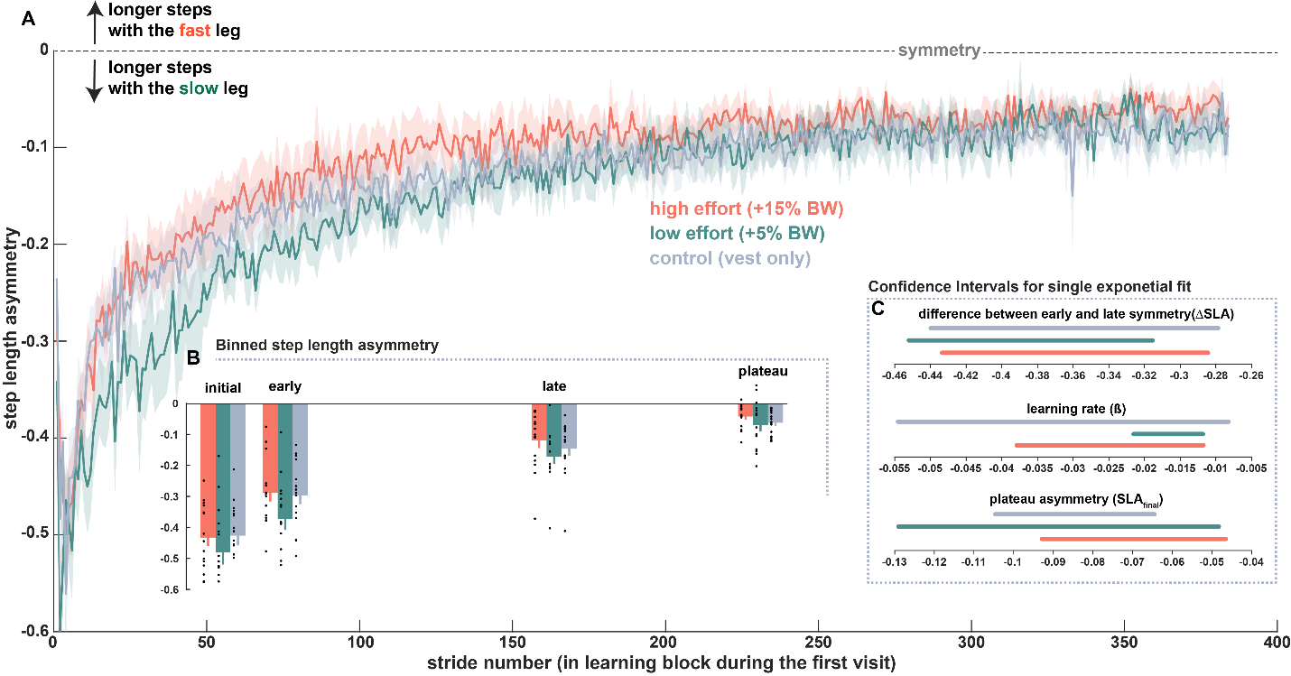
Figure 6: Step length asymmetry during split-belt learning
Step length asymmetry A) step length asymmetry for strides during the learning block. B) binned step length asymmetry for initial, early, late, and plateau. C) confidence intervals for exponential fit parameters showing how the intervals overlap.
State space learning fits: Each participant’s SLA curve was fitted with a state space model with remembering factor (α) and learning rate (β) parameters. Remembering factor, representing what proportion of the asymmetry from the previous stride is carried forward into the next, was similar between groups (mean and standard error are included in Table ###). Pairwise comparisons also showed no differences between the remembering factor between any pair of the three groups (p_{high-low}= 0.359; p_{high-control} = 0.664; p_{low-control} = 0.638). Learning rate captures sensitivity to asymmetry or what proportion of the asymmetry the participant responds to in order to mitigate asymmetry on the subsequent step. A high learning rate indicates a high sensitivity to error and will result in rapid initial progress toward symmetry. In contrast a lower learning rate will progress more slowly toward symmetry. Learning rate was similar between groups (mean and standard error are included in Table ###). Pairwise comparisons also showed no differences between learning rate between any pair of the three groups (p_{high-low}= 0.139; p_{high-control} = 0.835; p_{low-control} = 0.477).
State space fit parameter | High effort | Low effort | Constant effort | One-way ANOVA
Remembering factor (α) | 0.97 ± 0.005 | 0.98 ± 0.005 | 0.97 ± 0.005 | p = 0.657
Learning rate ($β$) | 0.01 ± 0.001 | 0.01 ± 0.001 | 0.01 ± 0.002 | p = 0.554
Initial asymmetry (${\hat{y}}_{1}$) | -0.43 ± 0.028 | -0.48 ± 0.039 | -0.43 ± 0.031 | p = 0.463
Exponential learning fits: Step length asymmetry curves were descriptively modeled for each participant using a single exponential function. When fit across all strides of the first learning block, single exponential fits showed no differences in the exponential coefficient (change in symmetry, $∆SLA$), exponential learning rate (β), or the exponential constant (final asymmetry, ${SLA}_{final}$) for step length asymmetry. Means and standard error for the exponential fit parameters are included in Table ###. Fit parameters were compared between groups using one-way ANOVAs. Pairwise comparisons also showed no differences between exponential coefficient (p_{high-low}= 0.338; p_{high-control} = 0. 780; p_{low-control} = 0. 332), exponential learning rate (p_{high-low}= 0. 316; p_{high-control} = 0. 395; p_{low-control} = 0.107), or exponential constant (p_{high-low}= 0. 322; p_{high-control} = 0. 791; p_{low-control} = 0. 330).
Exponential fit parameter | High effort | Low effort | Constant effort | One-way ANOVA
Coefficient ($∆SLA$) | -2.07 ± 1.657 | -0.45 ± 0.040 | 2.91 ± 2.490 | p = 0.597
Learning rate ($β$) | 0.03 ± 0.007 | 0.03 ± 0.005 | 0.05 ± 0.011 | p = 0.222
Constant (${SLA}_{final}$) | 1.59 ± 1.653 | -0.07 ± 0.023 | 2.39 ± 2.487 | p = 0.591

Model fit bootstrapping: To improve our confidence in these results, we bootstrapped the state space and exponential fit data in two ways. In the first bootstrapping protocol, we resampled individual’s SLA curves and fit the group average curves using the state space and exponential models. In the second protocol, individuals’ state space and exponential fit parameters were resampled. We followed each of these two protocols for each of the two models (2 x 2) and repeated sampling 10000 times, generating approximate population distributions for each of the model parameters.
Both bootstrapping protocols result in similar distributions between the effort conditions for both models. In all four cases, 95% confidence intervals for the bootstrap data overlapped for all parameters.
State Space Fit Bootstrap
Procedure 1: resample SLA curves | High effort CI | Low effort CI | Constant effort CI
Remembering factor (α) | [0.991 0.997] | [0.994 0.996] | [0.993 0.998]
Learning rate ($β$) | [0.002 0.010] | [0.003 0.006] | [0.002 0.007]
Initial value (${\hat{y}}_{1}$) | [-0.4733 -0.370] | [-0.555 -0.415] | [-0.487 -0.361]
Procedure 2: resample fit parameters | High effort CI | Low effort CI | Constant effort CI
Remembering factor (α) | [0.965 0.987] | [0.962 0.985] | [0.96246 0.98726]
Learning rate ($β$) | [0.008 0.013] | [0.008 0.011] | [0.006 0.009]
Initial value (${\hat{y}}_{1}$) | [-0.509 -0.368] | [-0.567 -0.372] | [-0.537 -0.405]
Table #: bootstrapped state space fit parameters

Exponential Fit Bootstrap
Procedure 1: resample SLA curves | High effort CI | Low effort CI | Constant effort CI
Coefficient ($∆SLA$) | [-0.423 -0.276] | [-0.448 -0.326] | [-0.372 -0.245]
Learning rate ($β$) | [0.0115 0.037] | [0.011 0.019] | [0.007 0.0343]
Constant (${SLA}_{final}$) | [-0.093 -0.050] | [-0.119 -0.045] | [-0.117 -0.065]
Procedure 2: resample fit parameters | High effort CI | Low effort CI | Constant effort CI
Coefficient ($∆SLA$) | [-0.512 -0.333] | [-0.519 -0.320] | [-0.562 -0.323]
Learning rate ($β$) | [0.021 0.048] | [0.017 0.040] | [0.020 0.070]
Constant (${SLA}_{final}$) | [-0.105 -0.003] | [-0.138 -0.032] | [-0.133 -0.072]
Table 2: bootstrapped exponential fit parameters
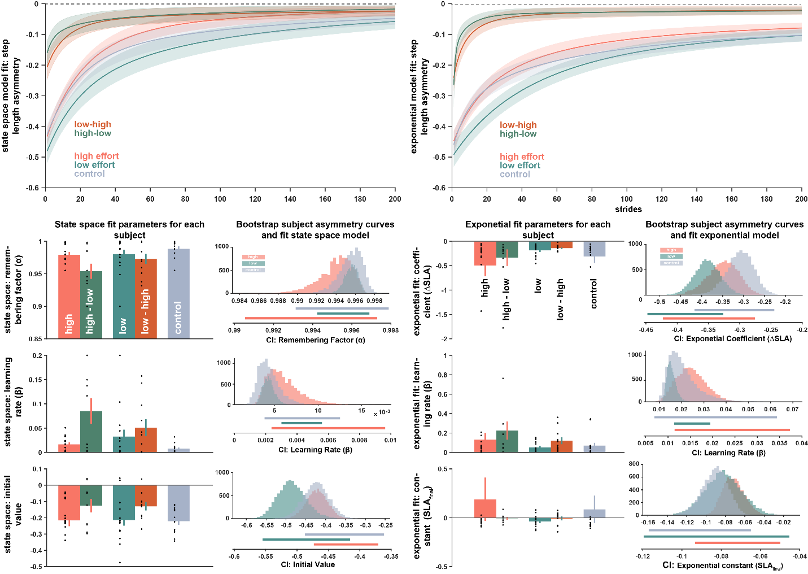
State space (left) and Exponential (right) model asymmetry curves, fit parameters, and bootstrap fit parameters

Linear mixed effects modeling: We generated a linear mixed effects model (LMER; equation 6) for step length asymmetry based on fixed effects of effort condition and log-transformed stride number. We included a random effect for each subject. As with the exponential fits, we ran the model for the whole adaptation and for a subset consisting of the first 200 strides. As there was no difference in the results, we report the model coefficients for the model based on the first 200 strides. Recall that, since step length asymmetry curves are negative, increasing SLA corresponds to increasing symmetry.
 | $$SLA \sim effort condition * log(stride number) + (1|subj)$$ | Equation 6
The linear mixed effect model results indicated a difference between the low effort and high effort conditions. Since effort condition is included as a factor, coefficients reported are relative to a reference. In this case, the reference is the high effort condition. Thus, the negative coefficient for the low effort condition (coefficient: -0.118; CI: [-0.184, -0.051]; p = 8.55e-4) indicates a decrease in the expected step length asymmetry based on being in the low effort condition. The fixed effect coefficient for the control condition is non-significant (see table 3 for complete list of coefficient values, confidence intervals, and p values). Because of the learning process, the fixed effect for stride number is strongly predictive, corresponding to increasing symmetry over the course of adaptation.
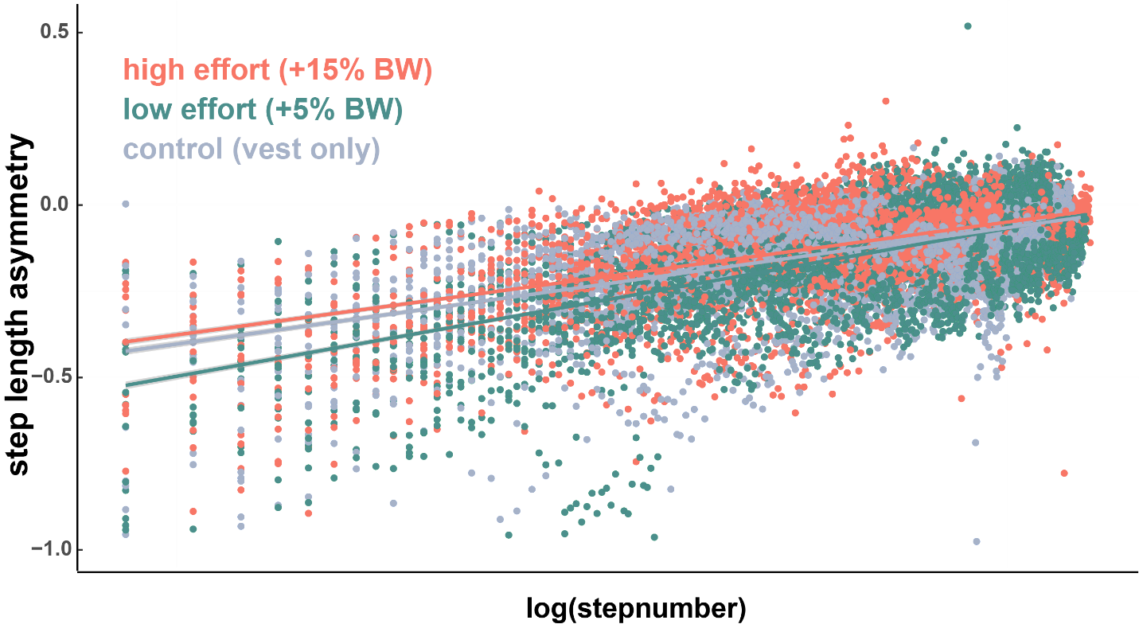
SLA versus log(*stride* number) shows how early strides have an outsized effect on the slopes fit for each effort condition.

Significance in the interaction terms (between low effort condition and stride number and between control condition and stride number) indicated that the relationship between stride number and step length asymmetry changed between the effort conditions. This interaction was significant even in the case of the control condition, where the fixed effect of effort condition itself was not a significant predictor. Both interactions are positive. For the interaction between the low effort condition and stride number, this means that as stride number increases, the negative effect of the low effort condition is attenuated. This is consistent with what we can see of the low effort group in figure 6. Visually, during the first 100 strides, the low effort group has more negative asymmetry (a result that is captured in the negative coefficient value for the low effort group in the LMER); however, beginning around 150 strides, asymmetry in the low effort group closely resembles that of the other two groups, suggesting an attenuated effect of the effort condition later in the adaptation period (captured in the positive interaction term between low effort and stride number). For the interaction between the control effort condition and stride number indicates that as stride number increases, symmetry increases more in the control effort condition.
Predictors of SLA (effort condition) | Coefficient value | Confidence intervals | p value
Low effort (vs high effort) | -0.118 | [-0.184, -0.051] | p = 8.55e-4
Control effort (vs high effort) | 0.020 | [-0.046, 0.087] | p = 0.549
Log transform of stride | 0.086 | [0.083, 0.089] | P < 2e-16
Interaction: low effort condition and stride number | 0.014 | [0.010, 0.019] | p = 3.25e-10
Interaction: control effort condition and stride number | 0.010 | [-0.145, -0.006] | p = 8.53e-6
Table 3: Split-belt LMER on learning block with fixed effect of effort condition
We generated a second linear mixed effects model which replaced the effort condition factor with a continuous fixed effect of normalized added mass (added mass / bodyweight). Coefficient values, confidence intervals, and p values are included in table 4. Because the added weight differentiated groups, this model can indicate differences related to added weight without a comparison to a reference group. This model showed no fixed effect of added mass. As before, there was a strong effect of stride number and a significant interaction between added mass and stride number suggested that the symmetry increases further at high stride numbers for higher added mass.
Predictors of SLA (added mass) | Coefficient value | Confidence intervals | p value
Normalized added mass | -0.001 | [-0.192, 0.189] | p = 0.989
Log transform of stride | 0.084 | [0.082, 0.087] | P < 2e-16
Interaction: normalized added mass and stride number | 0.002 | [0.012, 0.037] | p = 1.54e-4
Table 4: Split-belt LMER on learning block with fixed effect of added mass

…

